**Inbound Marketing Strategies & Benefits**

Our new digital age has really changed the face of marketing and sales with new techniques and strategies such as inbound marketing. **Inbound marketing strategies** allow marketers to easily convert potential customers to sales in a way that’s smooth and organic for both the marketers and their target audience. There are plenty of strategies involved when doing inbound marketing, as well as several benefits.

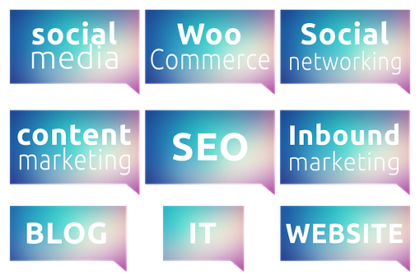

The **Inbound Marketing Strategies** include:

* **Search Engine Optimization** – strangely, search engine optimization or SEO is actually a marketing technique. It’s an important strategy that increases traffic to your website whether you’re actually marketing or not thanks to the proper use of carefully-placed keywords related to your product or service within your website’s content. It’s a smooth and passive method of marketing but requires much effort due to the potential amount of competition depending on the product or service involved. Nevertheless, this strategy is essential for what follows.

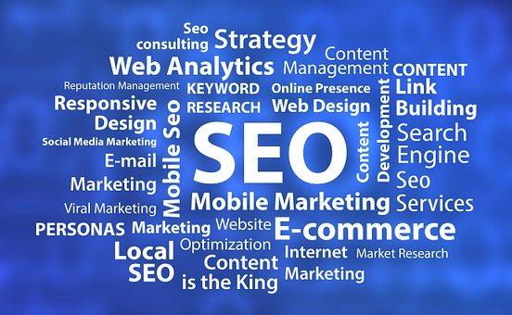

* **On-site content marketing** – is one of the essential **inbound marketing strategies** because people are always hungry for information, in other words, content for whatever interests them. Again, this is a subtle way of marketing which pushes a product or service to customers without them knowing it in the guise of information or entertainment. On-site content means this is content made exclusively for your website. If you’re already selling or sold your product, this strategy will keep your customer base engaged especially if the content is high quality. Marketing the content, not the product, in social media could also increase your chances of engagement. Plus, remember to embed SEO techniques in the creation of this content.
* **Off-site content marketing** – off-site content marketing is basically advertising your website via content you publish elsewhere. That elsewhere could be in social media in the form of Facebook Page articles or in already well-established and related websites. Having some compelling content could entice potential customers to click even an inconspicuous link to your website within the article. One technique done by several websites is to publish half or part of the article with a link to the full article to the official website. This will involve some cost though for the host.
* **Social Media marketing** – social media is the new dotcom boom but in a good way. Everything can now be found in social media and everyone and everything have been better grouped together. Like-minded individuals can group together, share ideas and even sell each other products. Social media is a whole new level where you can post both on-site and off-site content. Depending on your following, SEO won’t even be much of a problem. If you manage to engage one or several influencers to market your brand, your inbound marketing will flow much smoother.



* **Email Newsletters** – may sound a little passé but it’s still a method to push content especially for many who don’t bother with or have no time for social media. Theirs is still a significant percentage. Plus, including them in your newsletter email campaign will give them a slight feeling of importance or might simply annoy them. But the former is the true target.

**Benefits of Inbound Marketing**

* More customers – will come especially with more informative and helpful content. If your product for example is food related, keep bombarding your website with recipes and videos. Try to be subtle as customers are averse to advertising. Speaking of advertising, people on the web completely ignore or even block advertisements. Ads disguised as helpful content can get past ad blockers and reach and even engage with the target audience.
* Less Expensive – because authoring helpful content, especially targeted content is much less expensive than conventional marketing or advertising, especially when done through on-site marketing in conjunction with social media.
* A way to market and research – inbound marketing strategies such as social media, on-site and off-site content marketing are a good way to market product and provide the perfect way to perform market research especially if the audience is given the chance to react and engage.
* Newsletters – are not to be underestimated as they are still a good way to engage much of the workforce that cannot afford to be on social media. Email marketing is virtually free thus having the most return of investment. The only difficult thing about it is getting the emails but that’s where the other inbound strategies come in.